**Documentation for Negotiation Bot Implementation**

Name: R Rishikkanth

Contact: rishikkanth.ai@gmail.com

GitHub: RIS7567

# Overview:

This document provides a detailed explanation of how the OpenAI API and sentiment analysis are integrated into a Flask-based negotiation bot. The bot handles negotiations by adjusting responses based on user sentiment and input prices.

# Components:

* Flask: A web framework for building APIs with Python.
* OpenAI: Used for generating negotiation responses and sentiment analysis
* CORS: Used for handling cross-origin requests.

**Integration:**

## 1. Flask Setup

The bot is built using Flask, which is a lightweight web framework for Python. The Flask application is initialized in the file, and CORS is enabled to allow cross-origin requests. Also, import required libraries.

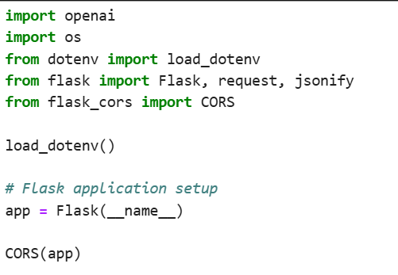

## 2. OpenAI API Integration

The OpenAI API is configured to generate responses for the negotiation bot. The API key is loaded from an environment variable using the dotenv library.



## 3. Sentiment Analysis

Sentiment analysis is performed using ChatGPT itself by assigning roles.

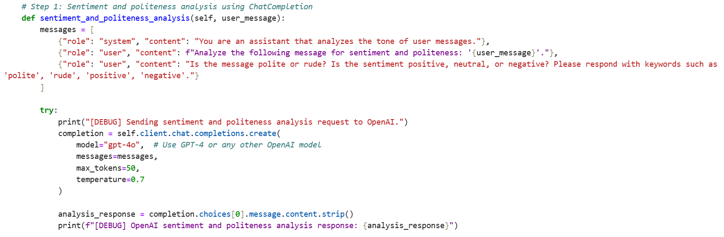

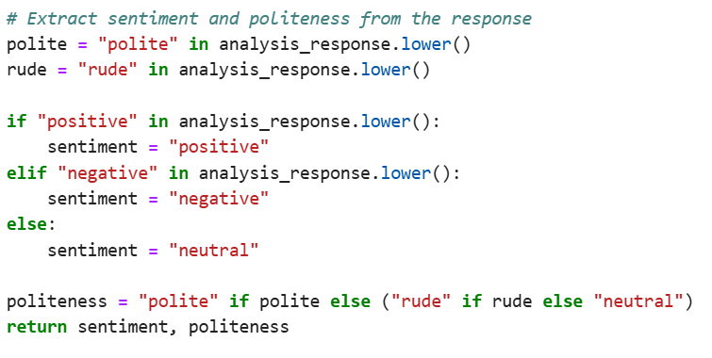

## 4. Negotiation Logic and Response Generation

The negotiation bot adjusts its response based on user sentiment and price input. The response is generated using OpenAI's API and returned to the user.

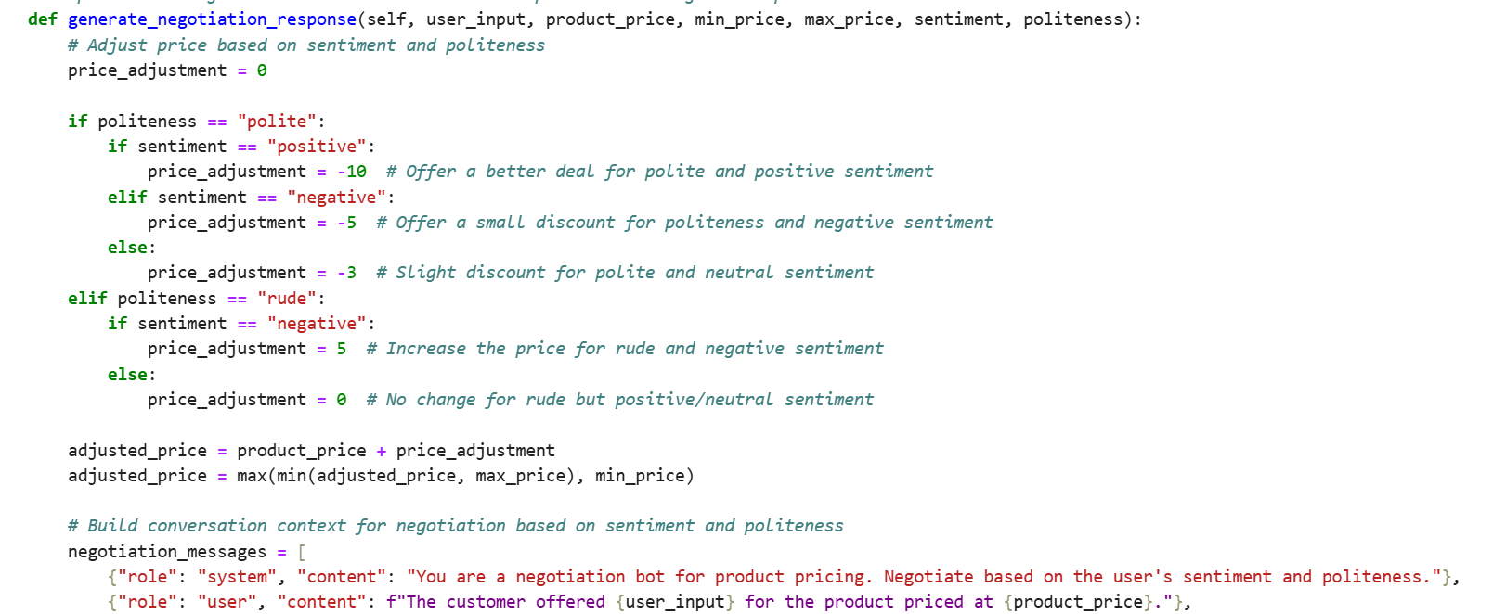

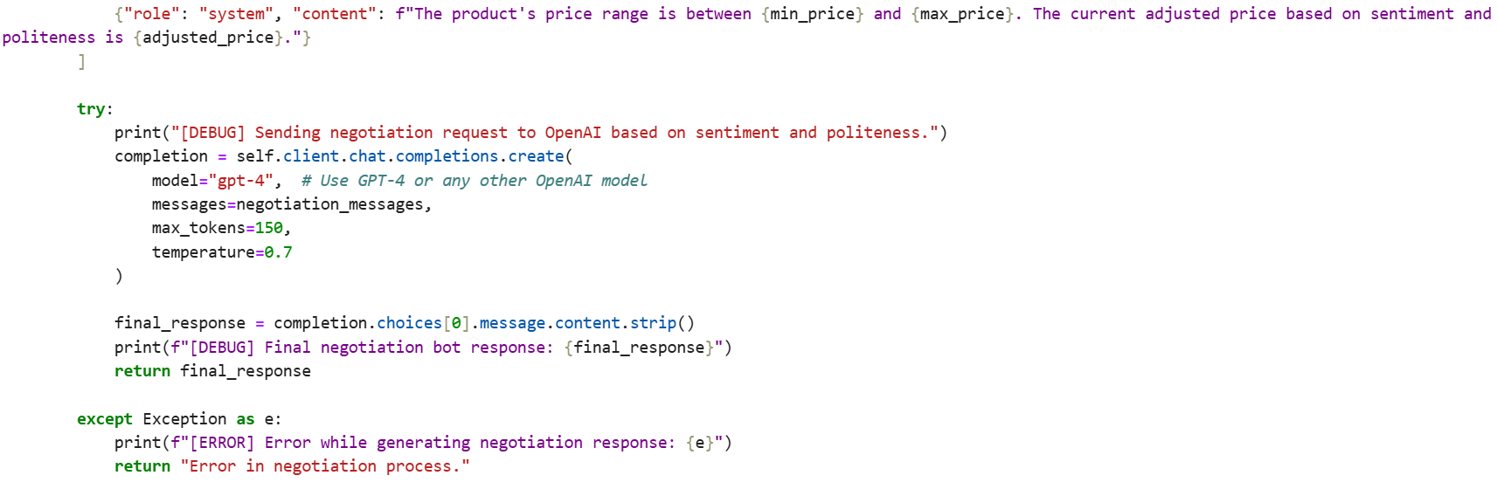

## 5. Flask Route for Negotiation

The `/negotiate` route handles POST requests with negotiation details. It accepts user input, performs sentiment analysis, and returns a negotiation response. (Local host= 5000)

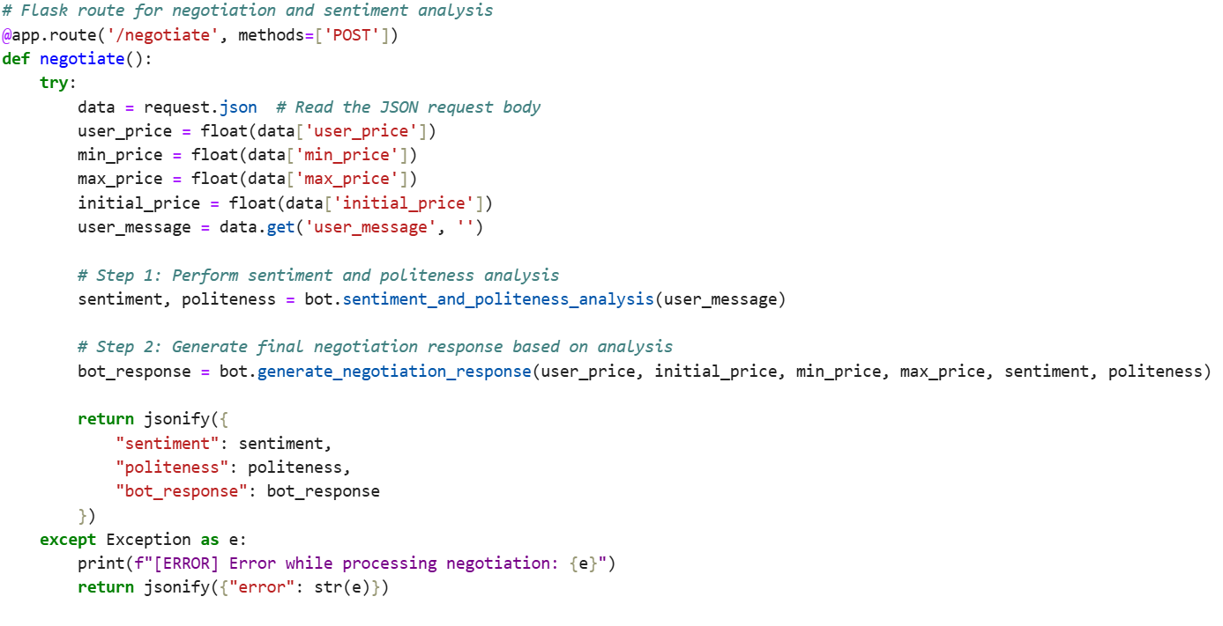

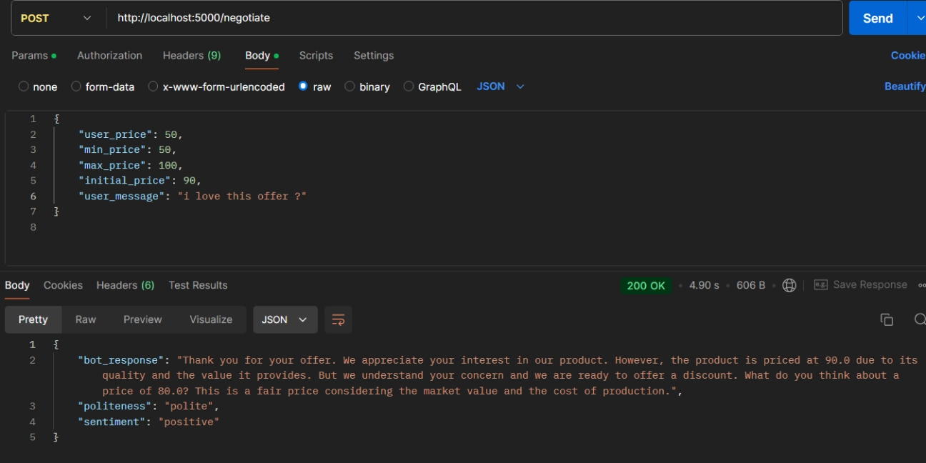

# Conclusion

This documentation outlines the integration of OpenAI and sentiment analysis into the Flask-based negotiation bot. By leveraging OpenAI's generative capabilities and TextBlob's sentiment analysis, the bot dynamically adjusts its negotiation strategy based on user input. Flask's lightweight framework and CORS enable a robust API structure for further development and integration.